Dear Fresh Service,

I have a lot of suggestions. To be fair, you might be interested in the fact that I test software for a living. I know how user friendly tools like this SHOULD be.

Fresh Service does not allow custom column headings in list display
I need to be able to select any fields to be part of my custom Display. For example, for Assets, I can see only Display Name, Asset Type, Location, Used by, Department and Managed by. I need to be able to use custom fields on this screen as well. Side note, Managed by is not sortable (all fields should be sortable).

Fresh Service does not retain screen set up
Launch FS
Select Asset Hierarchy
Select Hardware
Select IBM Sensor
Sort by Display Name
Select any entry from the list to look at the record
If I select the Browser Back button, I lose all my information – including the fact that I was in IBM Sensor folder.
If I select the “IBM Sensor”, I lose the original sort.

Original sort:
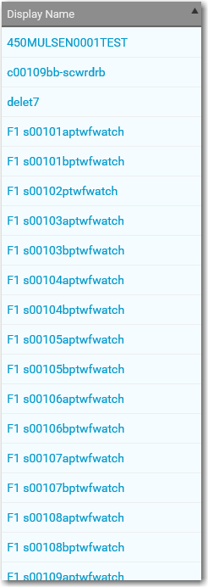

Select the entry near the bottom to display:

Select IBM Sensor:
This is what I see, it should be EXACTLY as the screen above, but it is not.
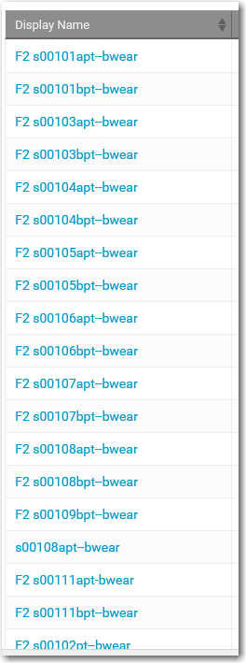

Filter
I need to be able to right click on an entry in the list and be able to select a FILTER function such as all those assets belonging to a certain location.
Here’s an example of how it looks in some other software we have:
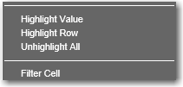

Custom Reports
I need to export data to Excel based on CRITERIA I select including the custom data fields.

So for this example, I filtered the screen as shown below:
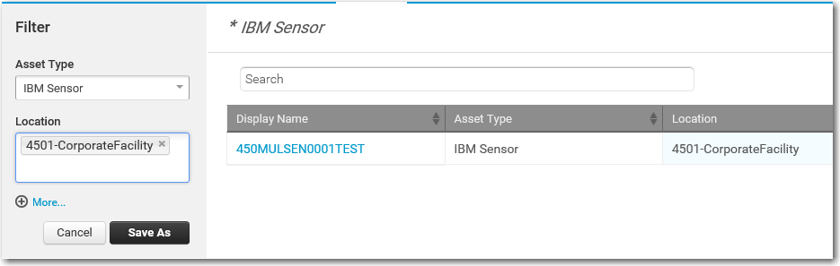

Here’s the detail for this record:
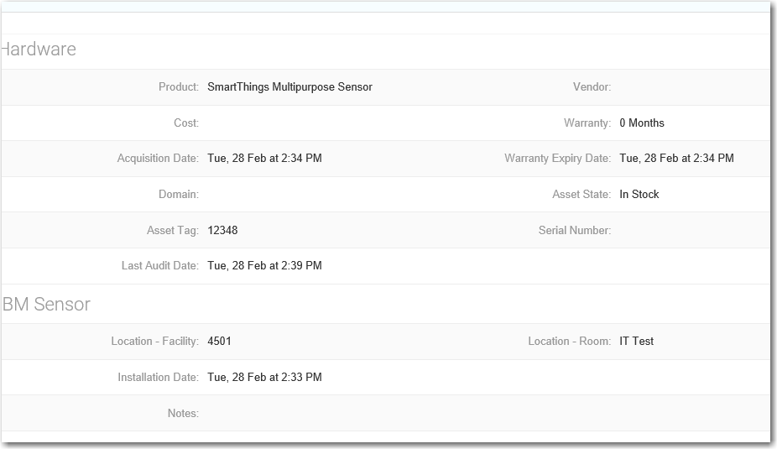

I then select EXPORT
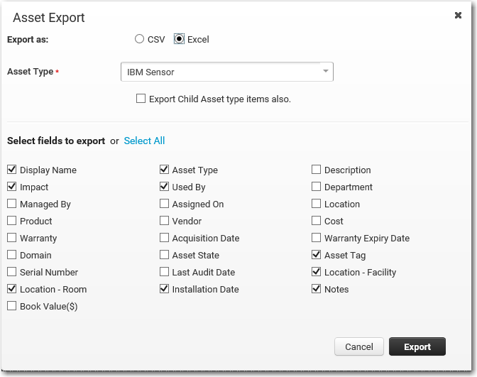

I selected Export after updating the options.

Cannot export to XLS format – I get this error when attempting to open the downloaded file:
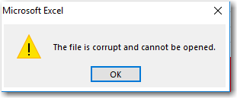

Here’s the version of Excel I am using:
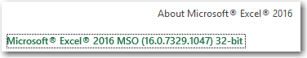

Try again with CSV format:
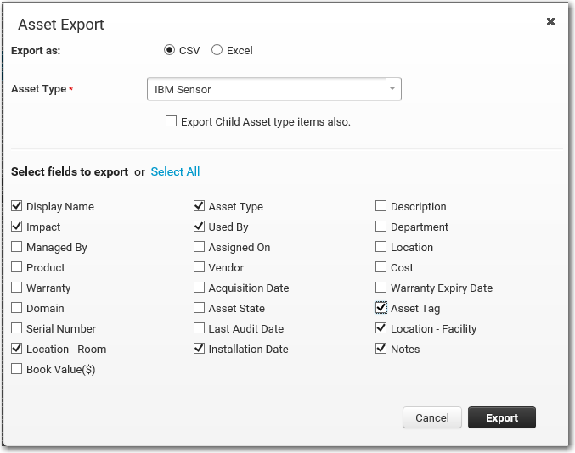
Select Export

The screen I am returned to is NOT the one I was on (it should be retained)
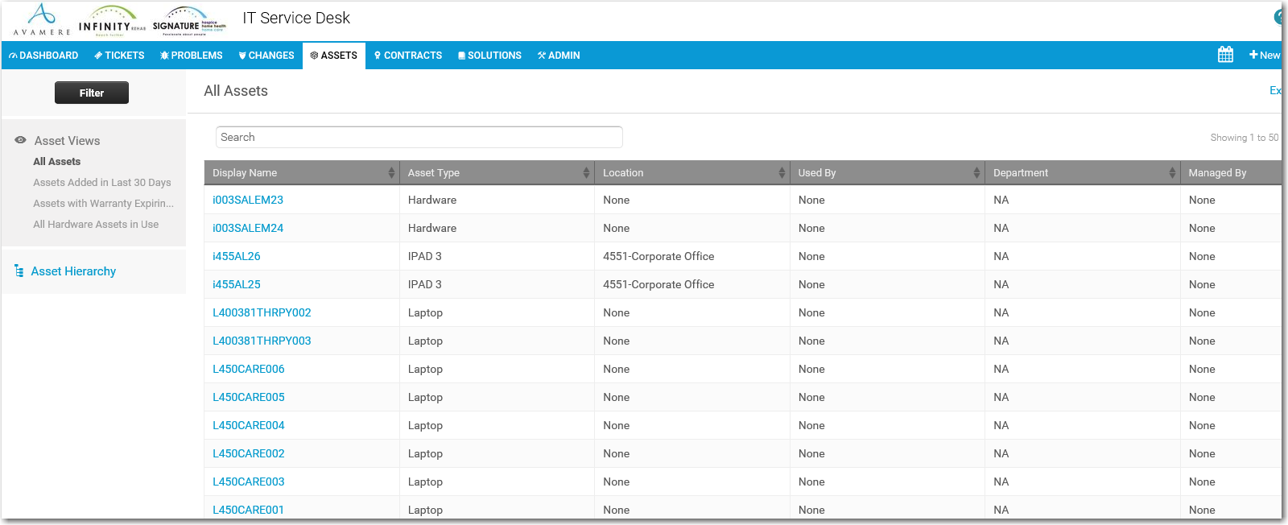
I retrieved the export link from the email (why doesn’t it just create a downloadable file without EMAIL?)

Which forces me to log back in - even though I never logged out. Another thing that should be fixed.
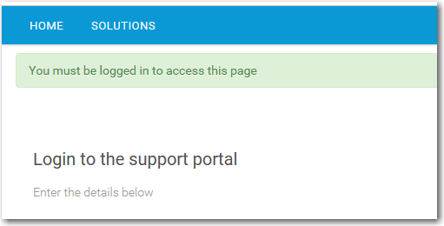

When I open the exported file this is what I see (not the FILTERED LIST) which is what I expected (this is just a partial screen shot).
