Configuring ADFS for Freshservice with SAML 2.0 Web SSO

On your ADFS Server, Open up AD FS Management

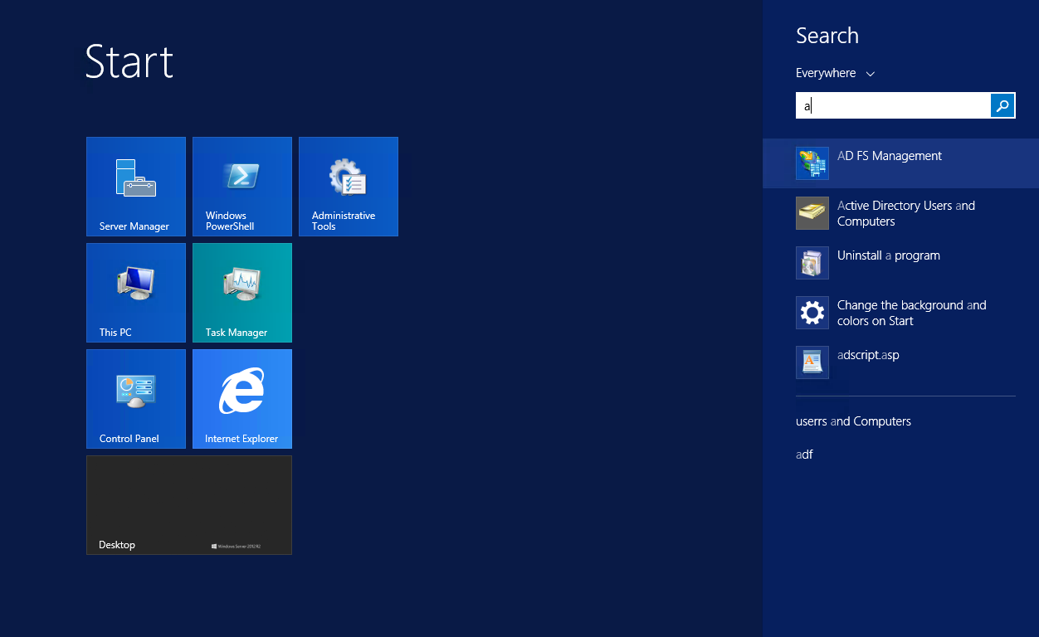

Right click on “Relying Party Trusts” and Select “Add Relying Party Trust.”

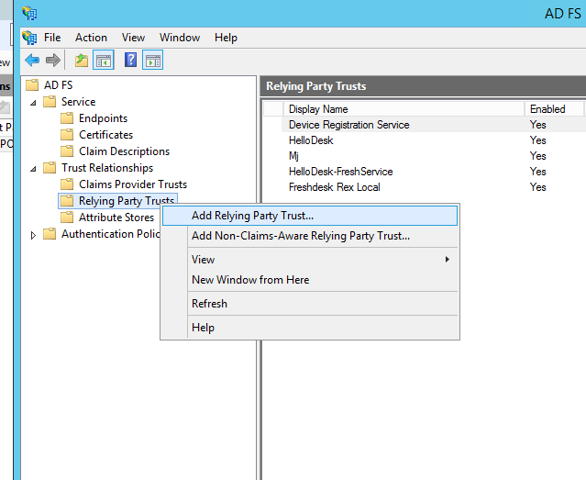

This would launch the Wizard. Choose the Manual Option and Key in a Display Name and Description for this Trust

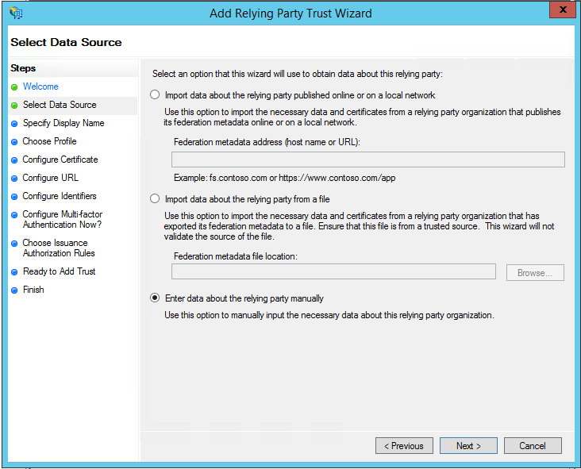

Choose ADFS profile with SAML 2.0 . Freshservice only Support SAML 2.0. On The subsequent Screen you need to choose SAML 2.0 and enter the login URL . The Login URL is https://<yourdomain>.freshdesk.com/login/saml .. Example . If your Freshservice Portal URL is https://support.myapp.com then your SAML login url would be https://support.myapp.com/login/saml.

Note : you should always use a HTTPS URL

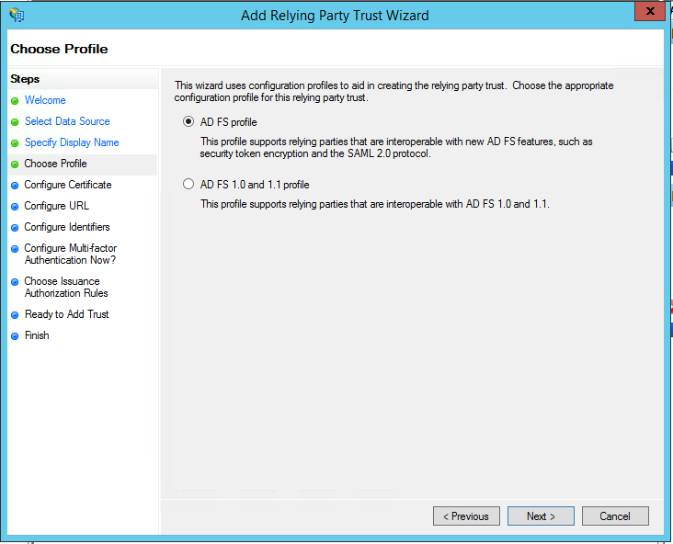

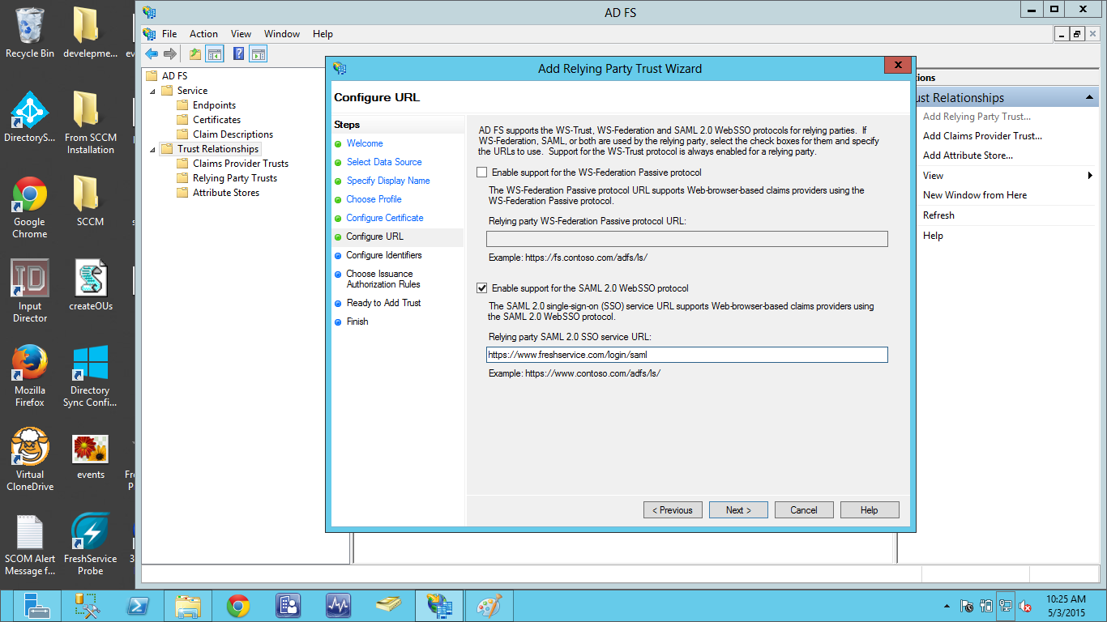

This should add a new relying party in your ADFS Service. Choose to Open the Edit Claim Rules dialog before clicking finish to edit further configuration. It should launch the Edit Claim Rules dialog shown below.

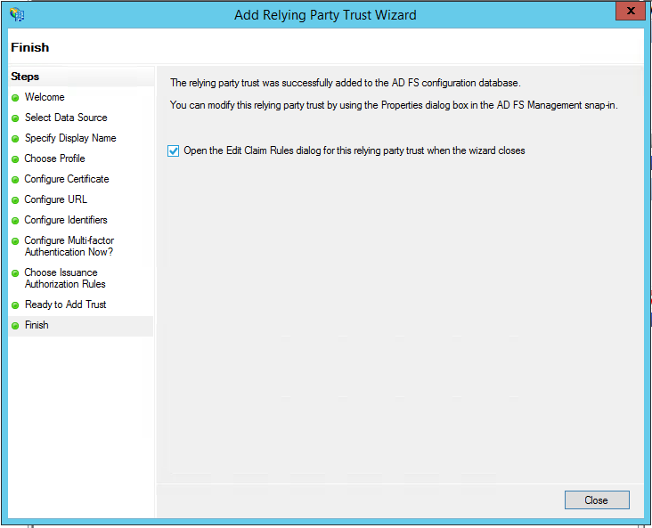

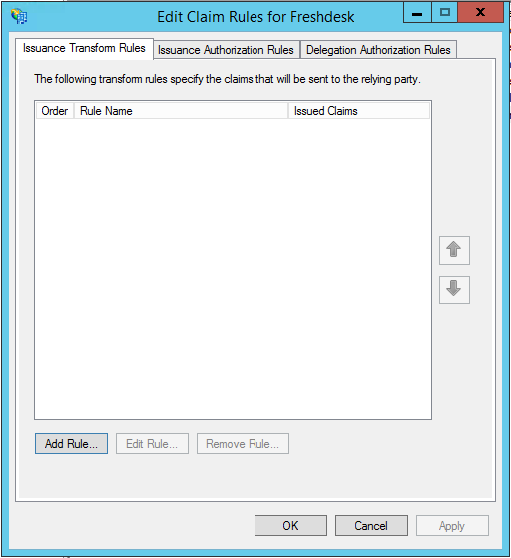

Freshdesk can accept Email, First Name, Last Name, Company and Phone number. You will need to pass these parameters from the LDAP rules.

Click on “Add Rule” and Choose Claim Rule as “Send LDSP Attributes as Claims”
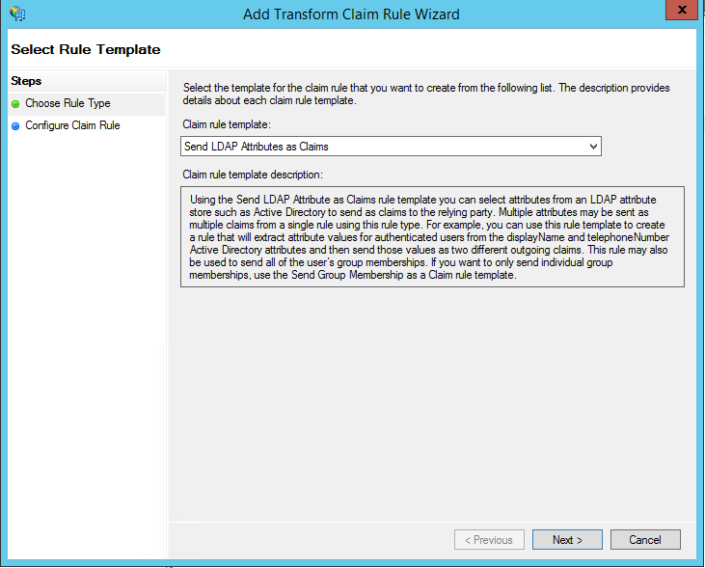

You can add the Outgoing claim Type as shown in the image here.

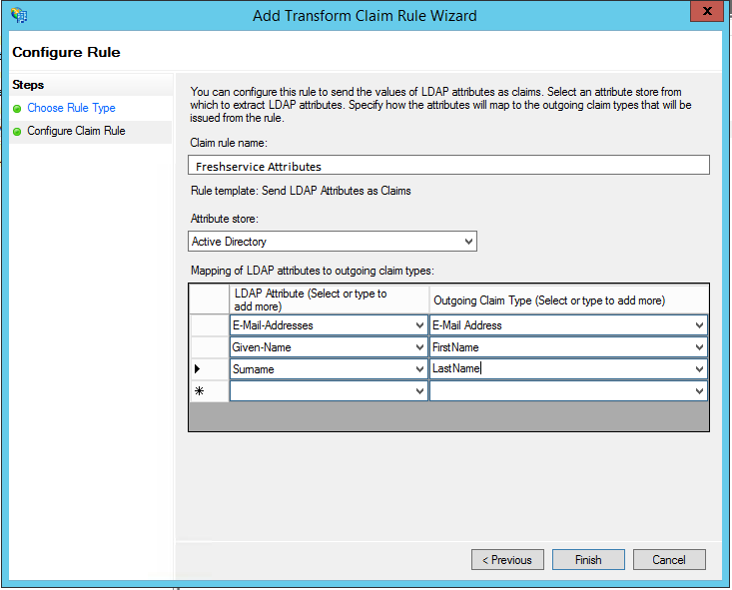

Click Finish. Freshdesk uses Email of the user as a login ID. In order for this to work, you need to set up the Email to come in as the NameID on the SAML login request . This can be achieved by setting up a Transform Rule.

Click Add Rule again and choose “Transform an Incoming Claim”

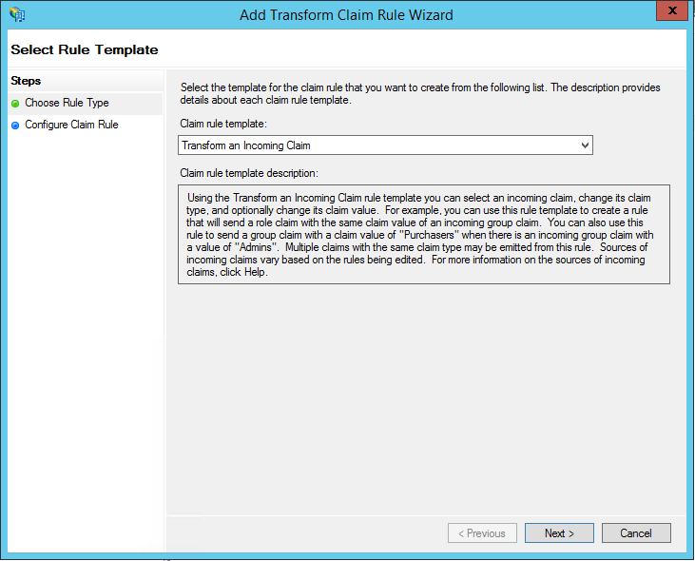

Setup Email ID to be sent as NameID by configuring as follows.

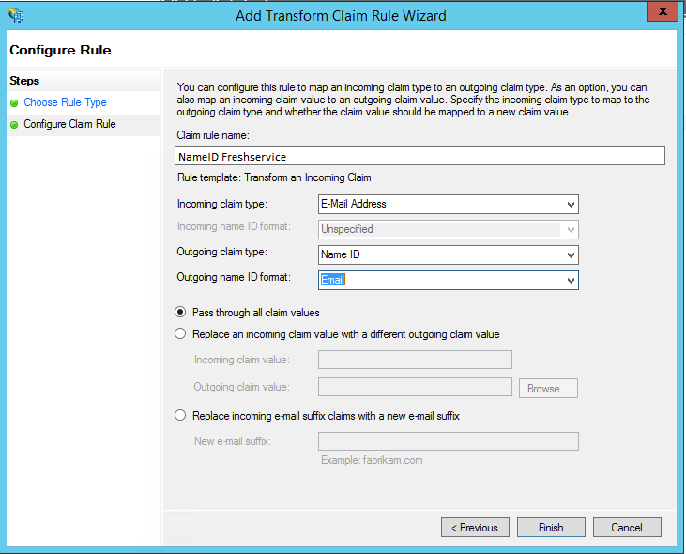

You should have something that looks like below. The order has to be maintained (LDAP Attributes followed by NameID Transform)

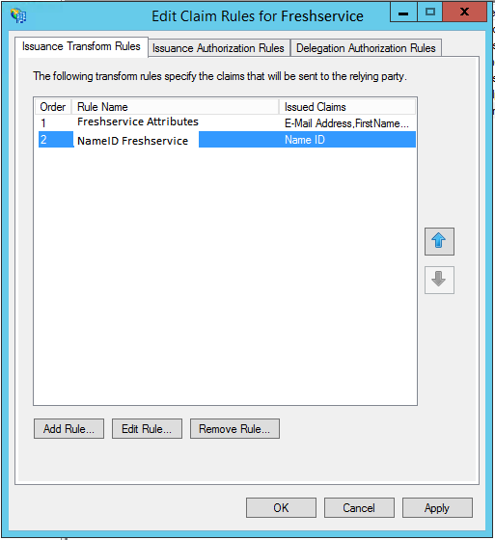

Now Right Click on the Relying Party for Freshdesk and choose properties.

Under Advanced Tab, Choose SHA-1 as the Secure hash Algorithm
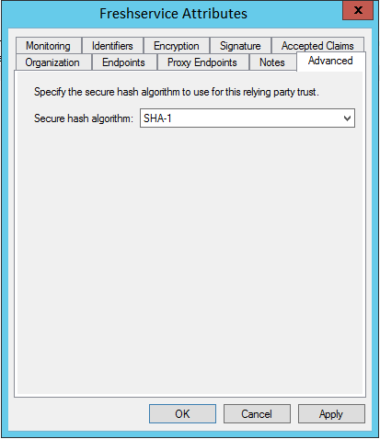

Make sure you have the domain listed under the identifiers section with both https and just the domain as follows.

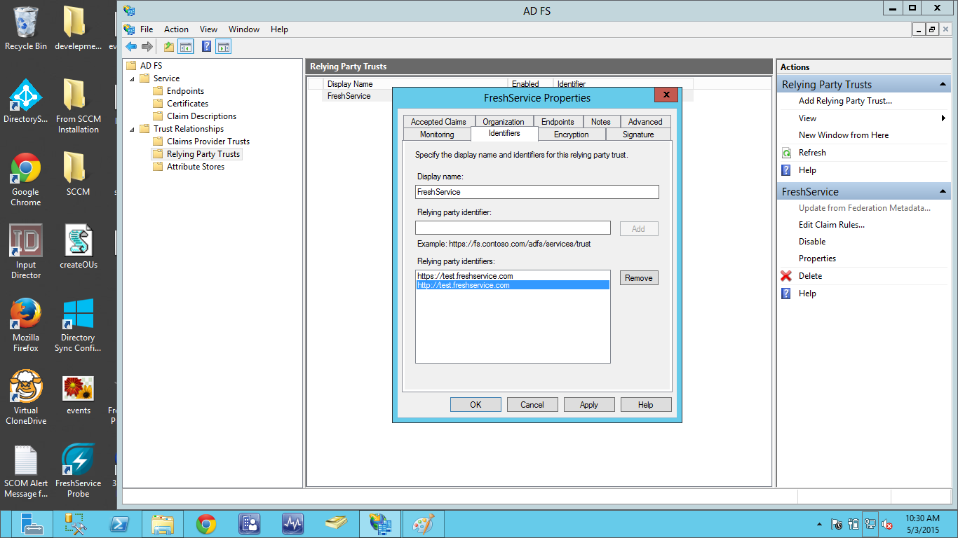

You are all set to use SAML with ADFS on Freshservice .

Login to Freshservice.

Now under the Admin Panel -> Security.

Choose SAML SSO under Single Sign on.

You need to configure the login URL for your ADFS Server and the Certificate Finger print. This is a SHA1 fingerprint of the certificate that can be seen on the properties tab of the certificate.

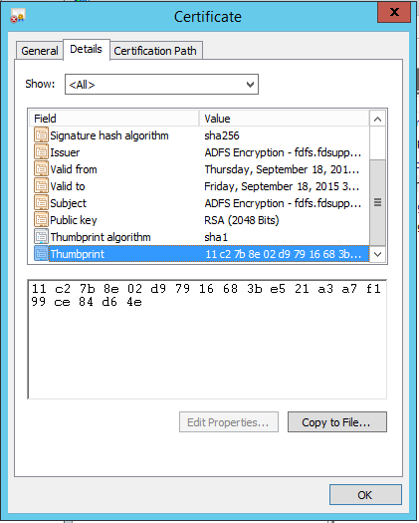

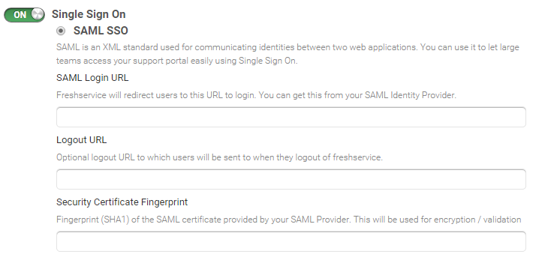
You are now set to login with ADFS SAML SSO in Freshservice.

Contact support@freshdesk.com if you have any questions or clarifications.

